~Asia-China-Mirror-W. Han-TLV-Eight figures, 8 and 12 Boss

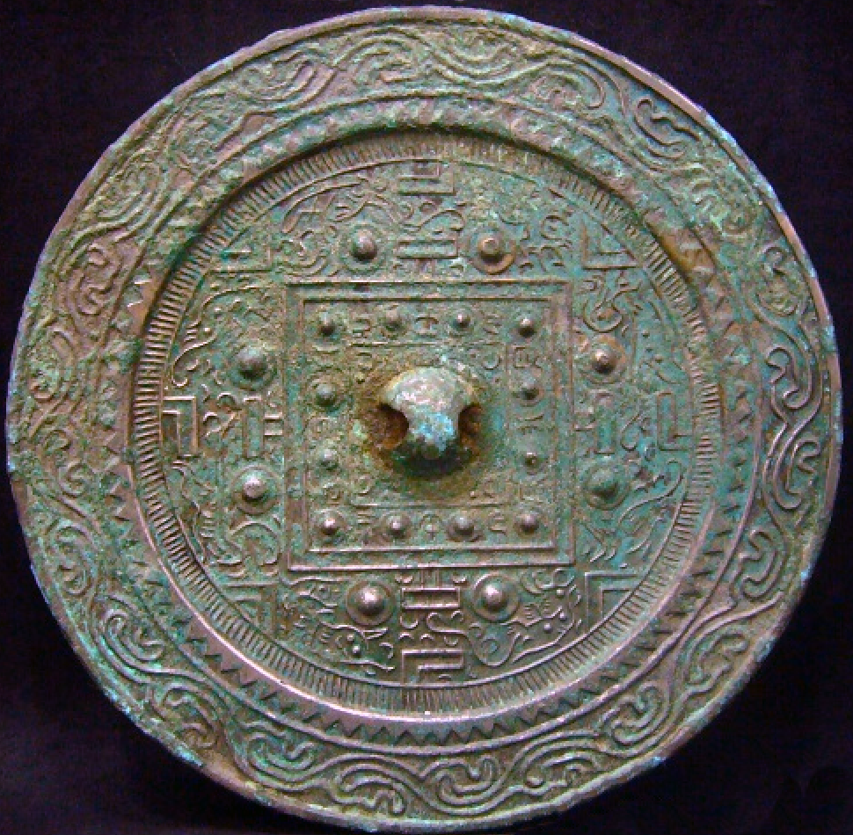

W. Han (206 BCE-8 CE), late 1st century BCE-TLV-Eight figure, 8 and 12 boss mirror, ca. 8 CE. Diameter 130  mm, thickness,  4  mm.

This TLV mirror is characterized by the four spirits in the quadrants beyond the square with an added four figures to accompany them, producing a total of eight figures. It has been reasoned that this addition of four figures to the original Four Spirits was occasioned by "design fundamentals" rather than iconography: "First, let us assume that the TLV mirror of this branch began only with Four Spirits. In such a mirror, however, the TL axes were found to be less hospitable when the figures were to be placed between their horizontal bars. Those spaces provided far less liberal quarters than the two side pockets to the left and to the right of the TL axes. When so placed the Four Spirits would experience a major constriction in their middle, whereas their heads and hind quarters could indeed move about quite freely. Second, in such an arrangement the two side pockets would contain unused space, which must have inspired a strong , additive desire in the mirror smith. As a result, he decided on nipples with their bases to fill the void, and brought in additional figures such as feathered immortals and other creatures. Third, once these figures found their way into the TLV configuration, the next logical step would have been to reduce the scale of the Four Spirits so that they could be accommodated on just one side of the TL axis, allowing the rest, now enlarged in scale, to occupy the other side. In this way the classic scheme of the octet was born" (Chou 2000:45). Conversely, the additional four figures may reflect individual preference of the bronze smith or of the patron for whom the mirror was being produced, thereby giving the mirror the stamp of an individual personality. This octet design is thought to prefigure the octet designs of later TLV mirrors (Guo 1996, pl. 62).

The Carter Collection example of this type dates to the earlier Western Han dynasty when a silver finish was applied only to the surface of the Four Spirits as confirmed by X-ray fluorescence spectroscopy (Chou 2000:115). The present mirror has no such silver finish, and so it probably dates to the later Western Han dynasty toward the turn of the millennium when this mirror was produced in greater numbers. This mirror is important because it confirms the longevity of this design, which extends from the beginning of the Western Han dynasty to its end and even beyond since other examples have been found in contexts dating to 136 CE.

The inscription of this mirror is inside the central square and replicates the series of zodiacal signs子茸寅卵辰巳午未申西戌亥.

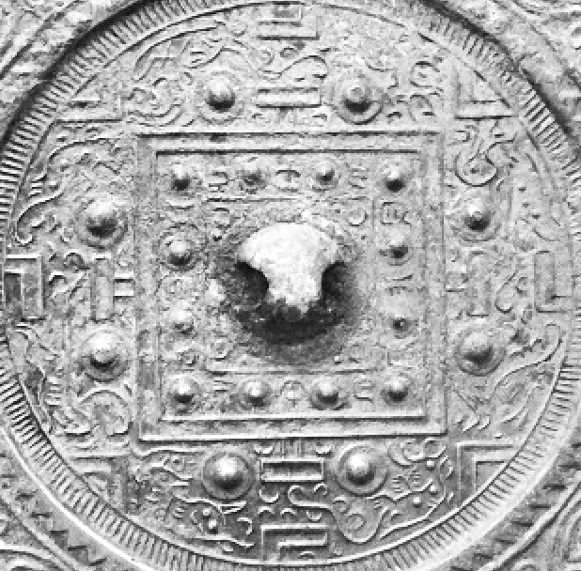

References:

# Chou, Ju-Hsi. 2000. Circles of reflection : the Carter collection of Chinese bronze mirrors. Cleveland, Ohio : Cleveland Museum of Art,

Yuhai Guo. 1996. Gu gong cang jing. 故宮藏镜 [Mirrors in the National Palace Museum] Beijing : Zi jin cheng chu ban she.